1. What is the correlation (R2 value) between sales and income?

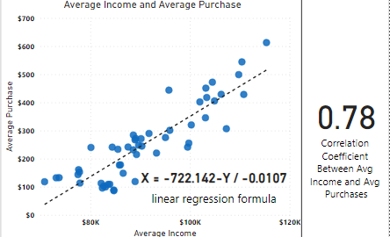

The R^2 = 0.78 which means that there is a strong relationship between Average income and Average Purchases which is also demonstrated in the scatter plot you can see how close the points are to the trendline and to each other.

1. What is the correlation (R2 value) between customer ratings and product return rate?

The R^2 value of 0.69 reveals a moderate relationship between customer rating and return rating The scatter plot demonstrates a discernible trend, with the points aligning fairly well with the trendline but not as strong as the relationship between the Average income and Purchases.

1. What are the linear regression formulas to predict customer sales and customer incomes?

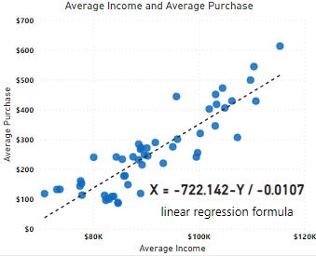The Linear regression formula is:

$$X= \frac{-722.142-Y}{-0.0107}$$

Where the X is the Average Income and Y is the Average Purchase. This formula allows us to estimate Average Income based on the Average Purchase values in the dataset

1. Which customer do you predict has the highest income?

Jon little is the customer with the highest income also the highest Purchases which makes since the more your income is the more you are going to purchase items. Also, this proves the high R^2 Value between Average income and Average Purchases was completely logical.

1. Which product will be advertised the most?

We can see from the above Donut Chart, which was made using the predicted income column, that the most frequently recommended product is shirts. Since most of our clients' income indicates that the shirts are the best fit product, it makes sense that we promote them the most.

**Findings from the research of 1-2 additional variables:**

1. A graph of blue squares

   Description automatically generated **A blue and black text

   Description automatically generated**

From the Histogram and these Cards, we can notice that the state of California is the one with the most customers, income, and purchases so we must focus on it more in our advertising campaigns Also that strength the logic behind the high R^2 value between the Average Income and Purchases.

1. A graph showing the amount of time

   Description automatically generated

This Line Chart between Purchases Amount and Date shows us that at the end of 2020 the company had a strong ending and good sales but in the start of 2021 it dropped significantly that indicates that their something went wrong in the company so in their in advertising campaign they need to focus more on the top 6 states by customer count, income amount and Purchases amount. Here is a summary of line chart:

* ﻿Purchase Amount trended down, resulting in a 96.25% decrease between Tuesday, September 1, 2020, and Monday, March 1, 2021.﻿﻿ ﻿﻿ ﻿﻿
* Purchase Amount started trending up on Tuesday, December 15, 2020, rising by 8.64% ($260) in 7 days.﻿﻿ ﻿﻿
* ﻿﻿Purchase Amount dropped from $12,677.7 to $2,252 during its steepest decline between Tuesday, September 1, 2020, and Monday, September 14, 2020.﻿﻿ ﻿﻿ ﻿